# Homework

## Software Development Models

### Guess which methodology corresponds to the diagram

Below you have 6 diagrams that represent 6 different development models, have a good look and fill your suggestions in the table below.

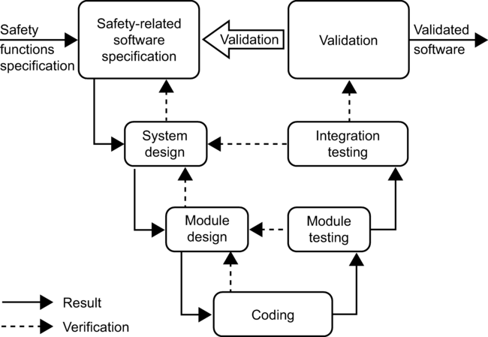

Figure

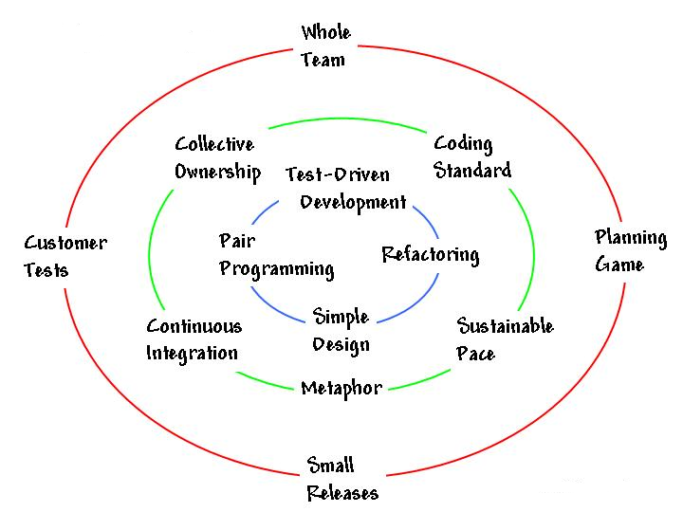

Figure 2

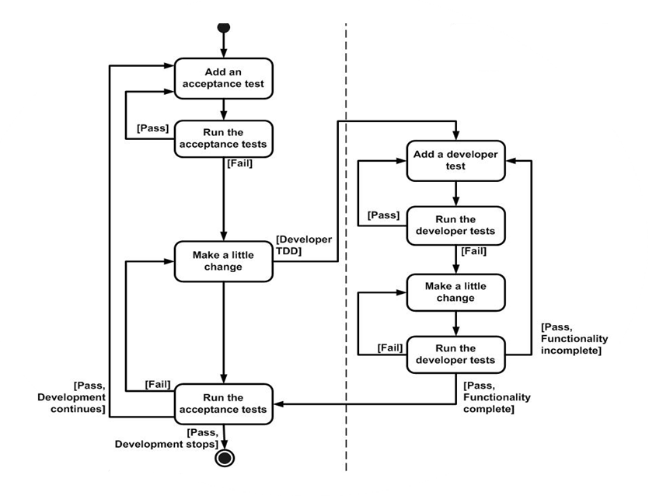

Figure 3

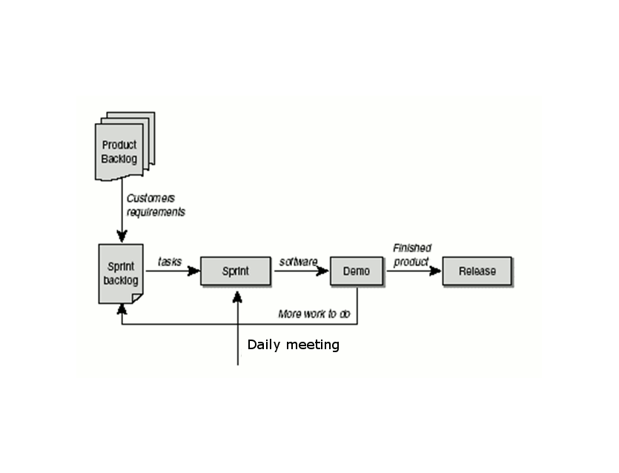

Figure 4

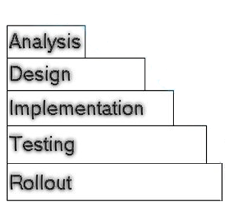

Figure 5

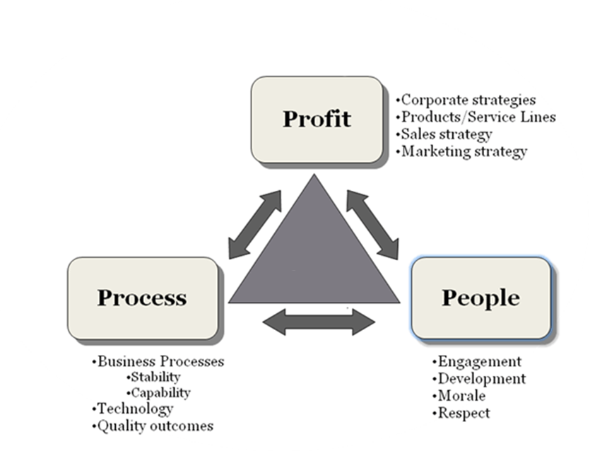

Figure 6

|  |  |
| --- | --- |
| Figure # | Methodology name |
| 1 | V-Model |
| 2 | Extreme Programming |
| 3 | Test-driven Development (TDD) |
| 4 | Scrum |
| 5 | Waterfall |
| 6 | ? |

*(6 positions X 1 point)* ***6 points***

### Compare the methodologies

Below is a table, where 3 different methodologies are compared. In the first row as a heading you see the names of the methodologies and in the first column there are the aspects of assessment. Your task is to give evaluation of the criteria from the first column by choosing the best suit from the boxes to the right of the table.

|  |  |  |  |
| --- | --- | --- | --- |
|  | Waterfall | Iterative | Scrum |
| Defined process | Required/Planning and closure only  Determined during planning/ Set during project  Determined during planning/ Set during project  Determined during planning/ Set during project  Limited – cookbook approach/ Unlimited during iterations  Planning only/ Throughout/At end of each iteration  Low/ Medium/ High  Training prior to project/ Teamwork during project |  |  |
| Final product |  |  |  |
| Project cost |  |  |  |
| Completion date |  |  |  |
| Responsiveness to environment |  |  |  |
| Team flexibility, creativity |  |  |  |
| Knowledge transfer |  |  |  |
| Probability of success |  |  |  |

*(24 positions X 1 point)* ***24 points***

### Which of the following artifacts/ events/ principles/activities belong to the listed methodologies?

|  |  |  |  |
| --- | --- | --- | --- |
| TDD | XP | Lean | Scrum |
| Design before you write your functional code | Courage | Eliminate waste | Product owner |
| Refactor | Pair programming | Keep it simple | Burndown chart |
|  | Metaphor | Identify Value | Daily Stand up meeting |
|  |  |  |  |

**Product owner**

**Eliminate waste**

**Courage**

**Design before you write your functional code**

**Burndown chart**

**Metaphor**

**Identify Value**

**Refactor**

**Daily Stand up meeting**

**Keep it simple**

**Pair programming**

*(11 positions X 1 point)* ***11 points***